**WEEK – 4**

**Name – Aditya Mishra**

**Registration Number – RA2111003011817**

**Section – M2**

1. **Create the below table and execute the insert, update and the below select statements.**

**i) Write a query to display the total number of recipes available with the description**

**“Chinese”**

**ii) Write a query to display the id, name of the recipes with chef_id 'BL000002'.**

**iii) Write a query to display the description of the recipes whose name begins with 'P'.**

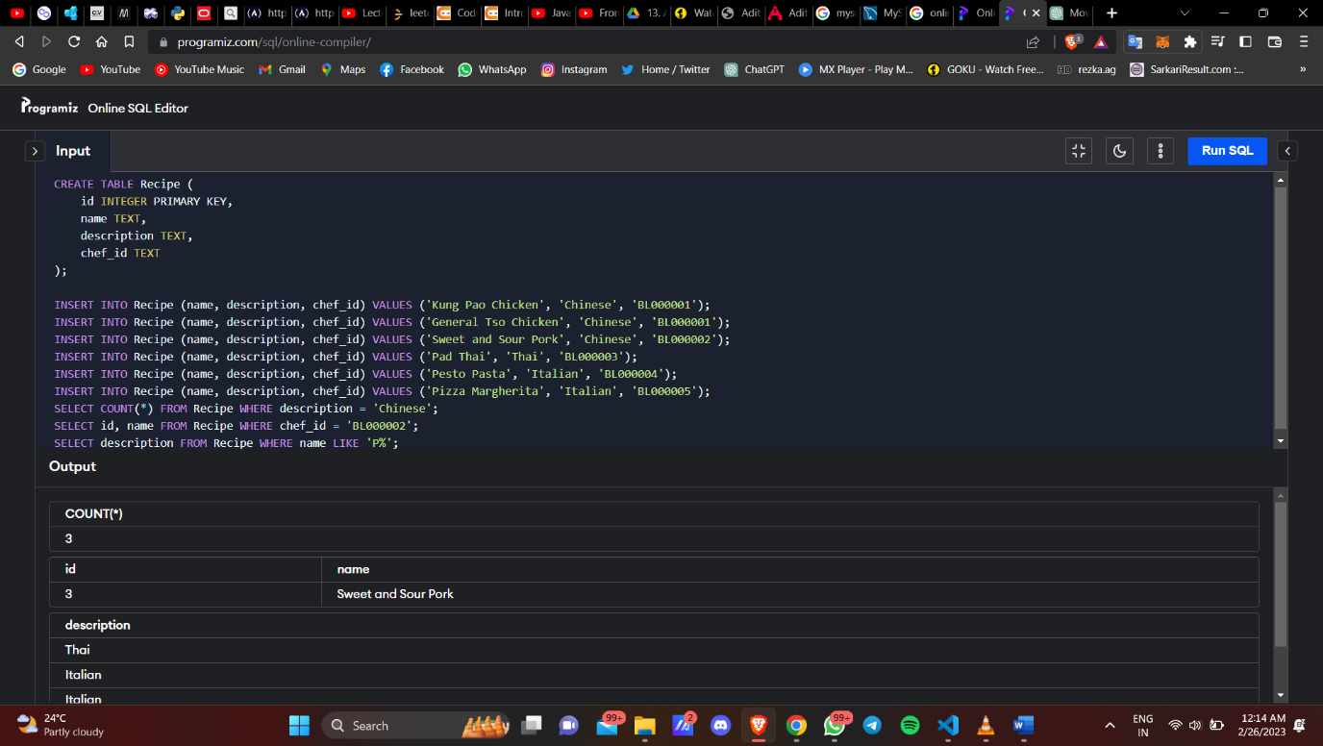

1. **Create a table movie of the below structure and assume data types.Movie_ID, Movie_Name, Genre, Language, Rating ,Do the following queries**

**a. Update the movies rating by 10% and display it**

**b. Delete the movies with movie_id 102**

**c. Select movies whose rating is more than 3.**

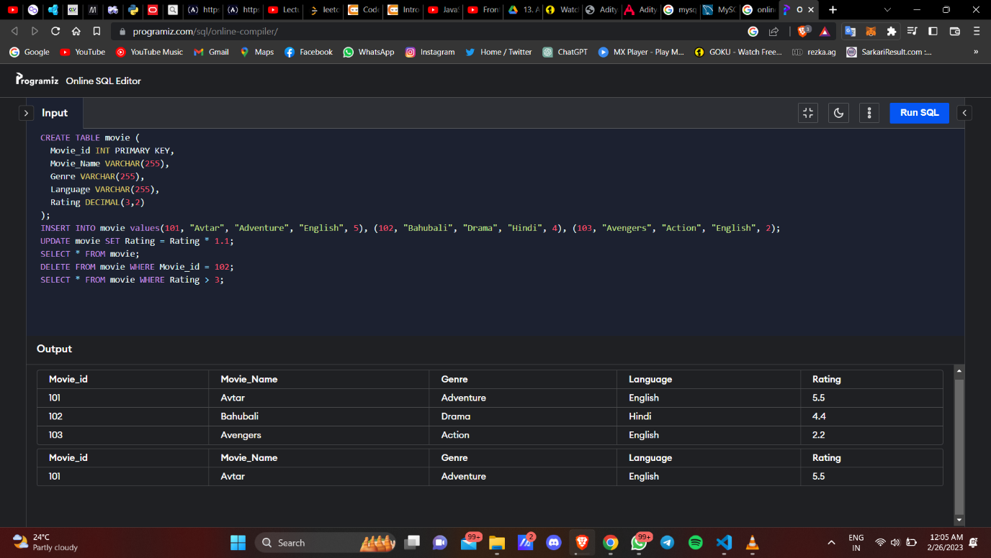

1. **Write a SQL lite3 statement to create a table named as job including columns**

**job_id,job_title,Min-salary,Max_salary.job_id column does not contain any duplicate**

**value at the time of insertion.**

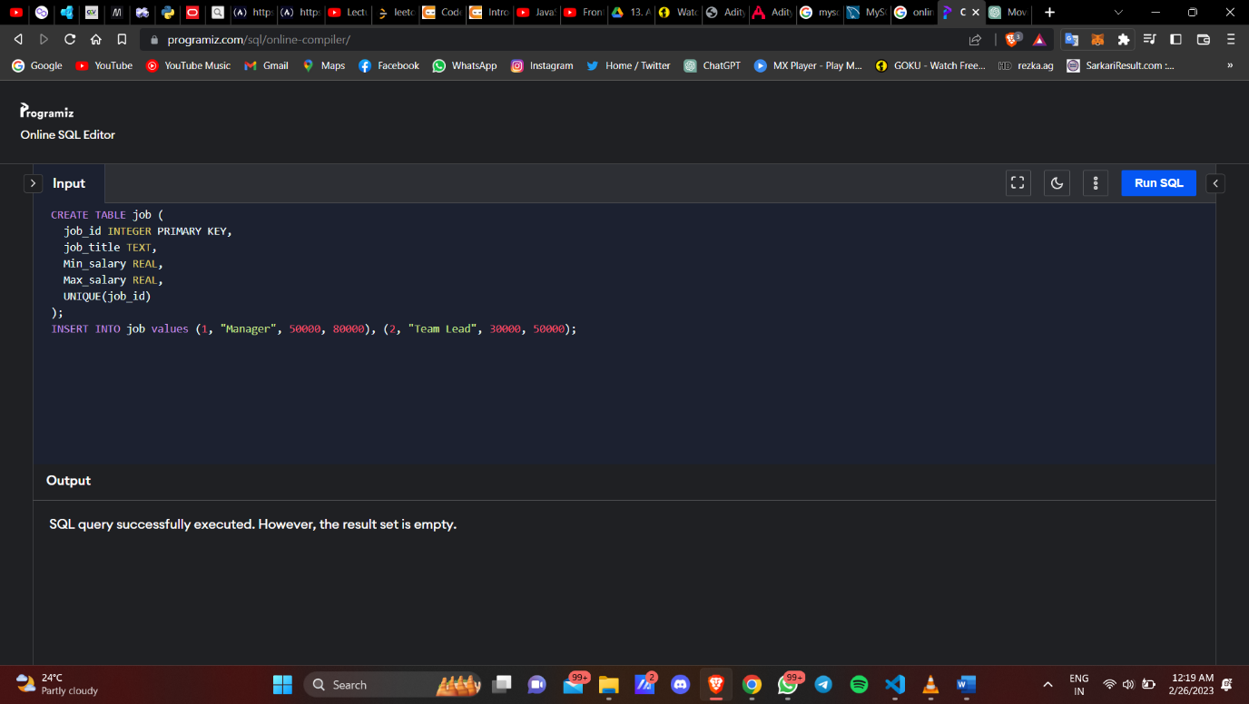

1. **Write a SQL lite3 statement to create a table names as job_history including columns**

**employee_id, start_date, end_date, job_id and department_id and make sure that, the**

**employee_id column does not contain any duplicate value at the time of insertion and the**

**foreign key column job_id contain only those values which are exists in the jobs table.**

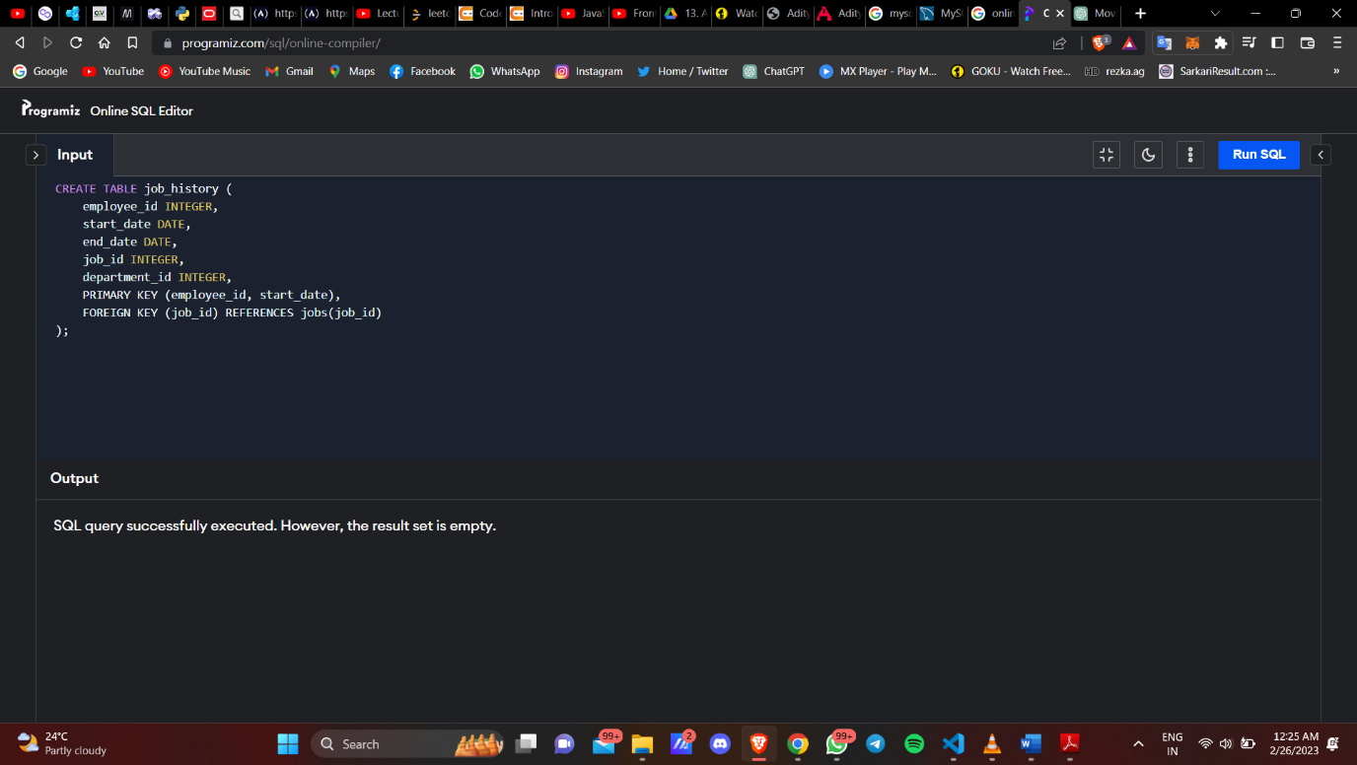

**Result -** Week 4 is completed.